Day 4 - Class Assignment

Name – Atul Ranjan (fs-18)

Q1 <https://leetcode.com/problems/remove-all-adjacent-duplicates-in-string>

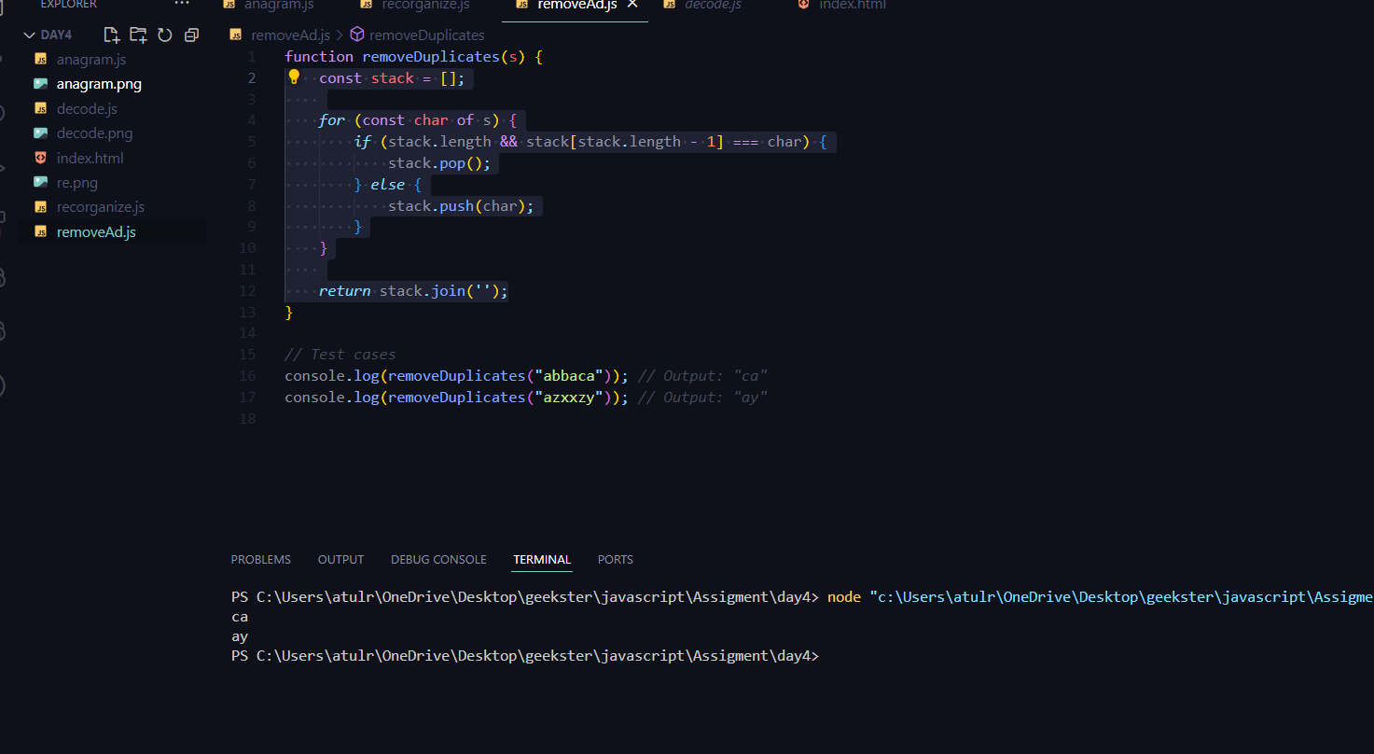

* Q2 Valid Anagram:- <https://leetcode.com/problems/valid-anagram>
* Q3 Decode String:- <https://leetcode.com/problems/decode-string/>

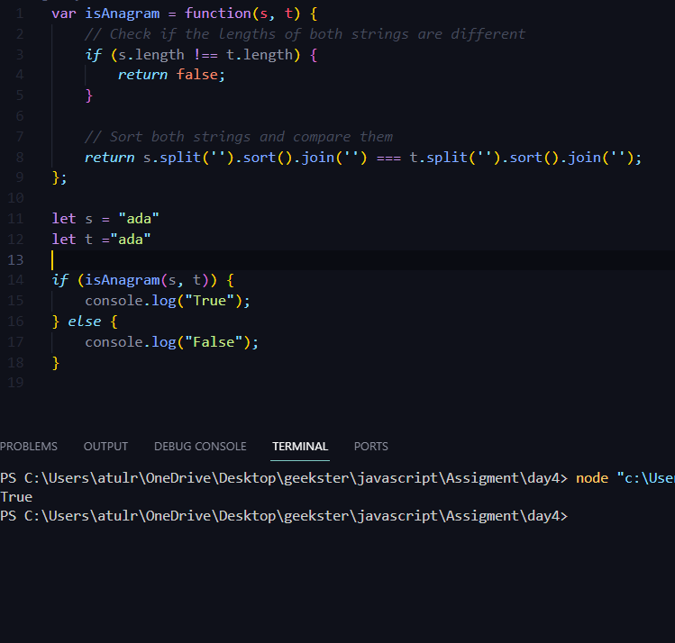

* Q4 Reorganize String:- <https://leetcode.com/problems/reorganize-string/>
* 